Exploration of the Invoice Spreadsheet

- Bring up the spreadsheet via this link: http://www.mrsherry.com/sb/invoice1.xls.
- Look at the contents of cell F2. Notice that it is a formula, so the formula line at the top has a formula in it that starts with the ‘=’ sign. What does this formula do?

- Look at cell F3:F18 (note the ‘Range’ format specification for ‘cells F3 through F18) under F2. How did you think they were entered?

- Try to change the value in cell F2. What happens?

Why do you think this was set up this way?

- Click on cell E2 and view its formula. Look at it in parts and see if you can tell what each part does:
MATCH(C2,invoice1.xls!Items,0)

INDEX(invoice1.xls!ItemCosts,MATCH(…))

IF(LEN(C2),INDEX(…),0)

- Click on the ‘PriceList’ notebook tab at the bottom of the window: 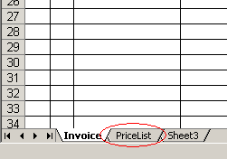
Look at the items specified and their prices.
- Switch back to the ‘Invoice’ sheet and create an invoice for the following items, starting with cell C2 and working down the spreadsheet (e.g. enter values for C2, D2 for the first item, then C3, D3, etc.).
Item Quantity
Pencil 24
Pen 12
Eraser 6
Ruler 1
White Out 6
Note what happens automatically.

What is your total?

- There is a problem with the price of White Out. Change the price of White Out to $1.39 and see what happens to your invoice.

