Excel Review

Moving Around

Selecting a Cell
- Use the Mouse or Keyboard.

Going to a Specific Cell
- Hit F5 or Type the name of the cell in the ‘Name Box’:
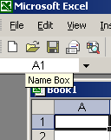

Selecting a RANGE of Cells
- Select 1st cell and then hold down ‘Shift’ and select the 2nd cell to select all cells between the two.
- Select 1st cell, then press ‘Shift’, move to the end cell, and release the mouse.
- Use Shift with the keyboard.
- The first cell in a selected RANGE appears differently than the rest.

Entering Data

Entering Labels
- Type non-numeric characters to start a label. It will be left justified.
- To enter numeric characters (0-9, =, etc.) as labels, precede them with a single quote (e.g. ‘1010)

Entering Numbers and Dates
- Type in numbers to enter a number (e.g. 10). It will be right justified.
- Type in a date in any reasonable format to enter a date. Note that if you leave off the year, it defaults to the current year

Formatting Cells
- Right click on the selected cell (or cells).
- Bring up ‘Format cells…’
- The tabs at the top are used for:
- - for formatting numbers, dates, currency, etc.
- Align the text within the cell (top, middle, bottom; left, center, right)
- Wrap text
- Angle text.
- - everything about the font. The color of the letters is here, but not the background.
- - Normally, lines do NOT appear around cells in the printout. Change that here.
- - Background color/patterns for cells.

Using Formulas

Starting a Formula
- Use the ‘=’ sign
- The Name Box to the left of the formula bar:
becomes a drop-down list of recently used functions:
- The three boxes to the left of the place you enter the formula work.
- The cancel button – to cancel input.
- The enter button – to accept a formula.
- The insert button – to insert a function

Entering numbers for your formula
- You can enter just a number: =10
- You can enter an algebraic equation using constants: =10/4

Using REFERENCES
- A reference is a pointer to another cell. When a reference appears in a formula, it is replaced with the value currently in that cell:
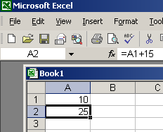
Note in the above example, cell A2 contains the formula =A1+15. Since the contents of cell A1 is currently 10, the formula becomes =10+15, or =25. Thus cell A2 shows a value of 25.

Using Excel’s built-in FUNCTIONS
- Pull down the ‘functions’ pulldown to get most recently used functions.
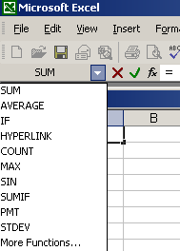
- If your function is not there, select ‘More Functions’
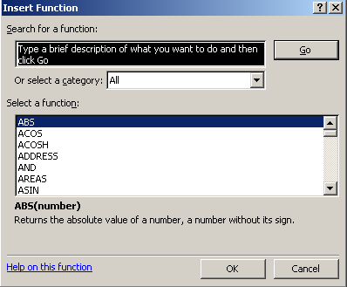
Note that you can select a category for what appears in the bottom box. You can also just type what you are looking for in the top box.
- When a function is selected, the text under the bottom box tells what the function does. Also, there is help on that particular function just under it:
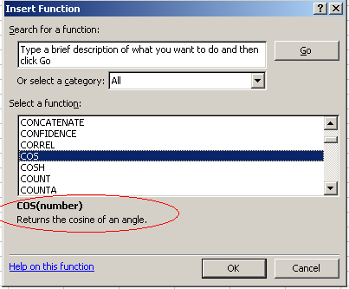
- Note that functions take arguments or parameters. For example, the COS() function takes a number which represents an angle to take the cosine of.
- For many functions (like SUM() or AVERAGE()), an argument can be a RANGE of cells, specified by the first cell in the range, followed by the last cell in the range. The range includes the two end cells and all cells inbetween them.
- When you press ‘OK’ to the window above, you get a box that provides more information.

Copying and Filling

Copying
- Select a cell or range of cells. Copy them, select a destination cell or range of cells. Then Paste them.
- To Copy or Paste, select the option from the ‘Edit’ menu or the right-click menu from the cell.

The Fill Function
- To copy information from ONE cell to MORE THAN ONE cell, use fill. You can Fill-Down and Fill-Right. Select the range, and the first cell in the range (the one that appears differently) gets copied to the rest of the cells.

Relative vs. Absolute References
- By default, references (e.g. A2, B5, and C9) are relative. When the formula is copied, the distance and direction of the reference from the position of the formula is maintained.
- This means that if the formula =A5+10 is copied down to a new location 2 cells below the current cell, it becomes =A7+10.
- Excel does this by remembering the position of the cells in the formula relative to the formula’s cell. Thus, in the following example:
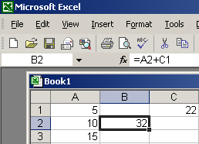
The formula is internally represented as ‘=<the contents of the cell one cell to the left>+<the contents of the cell one cell up and one cell to the right>’
When we copy the formula, the internal representation is maintained. So if we copy the formula to cell B3, the formula is still ‘=<the contents of the cell one cell to the left>+<the contents of the cell one cell up and one cell to the right>’, which is now
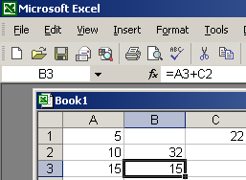
- To STOP THIS BEHAVIOR, nail down either the row, column, or both by putting a $ in front of the row or column in the formula:
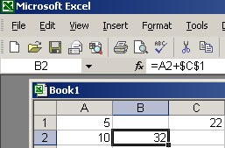

Print Formatting

Using Autoformat
- Just a convenient way of applying a pre-defined set of styles to an area on the spreadsheet.
- Lays out the area like a table in Microsoft Word.

Using Margins to center the printed area
- Adjust the way you lay out the part of the spreadsheet you entered on the physical page.
- In File…Page Setup, there is a Margins notebook tab for adjusting the margins.
- There are checkboxes in that margins tab that will allow you to automatically set the margins up to center the data you have.

