Creating a Report
- Create two queries. A nested (subquery) query and a join. Each should do the following.
  - Select the album name, track number, and track for all albums belonging to a specific artist.
  - Replace the Artist = “some artist name” with Artist = ChooseAnArtist. Since Microsoft Access will not see a table, track, or other database item with the name ‘chooseanartist’, it will prompt you for that value whenever the query is run.
- Test the queries.
- Go to the reports section of your database:
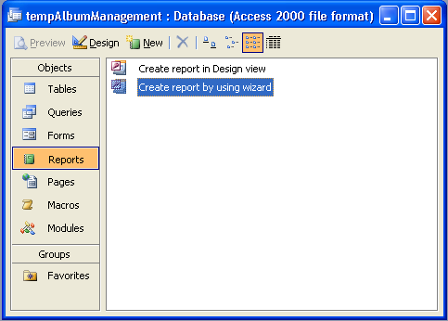
- Create a report using the wizard.
- Select your Nested Select Query:
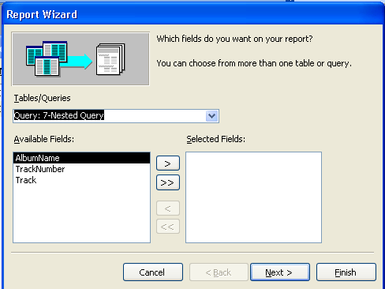
- Move ALL fields from the Available Fields box to the Selected fields Box and hit ‘Next >’.
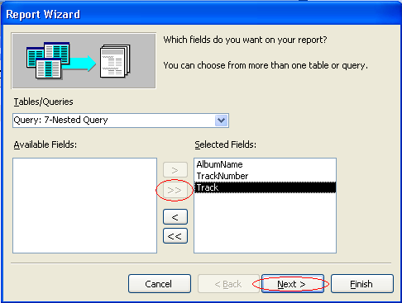
- Group the album name by selecting it and pressing the ‘>’ key.
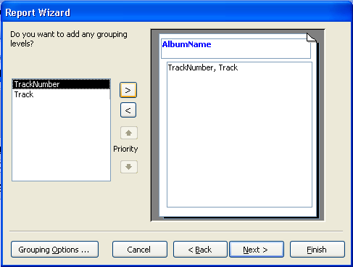
- Sort by tracknumber ascending:
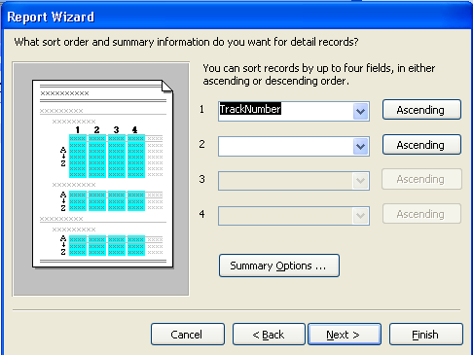
- Keep the stepped layout of the report:
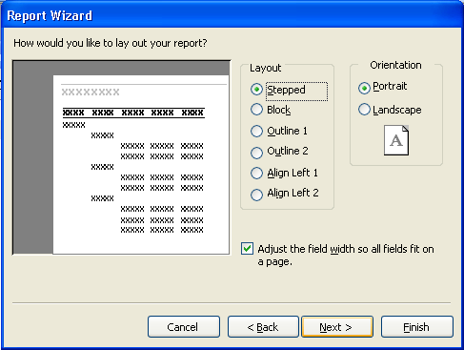
- Pick a style you like:
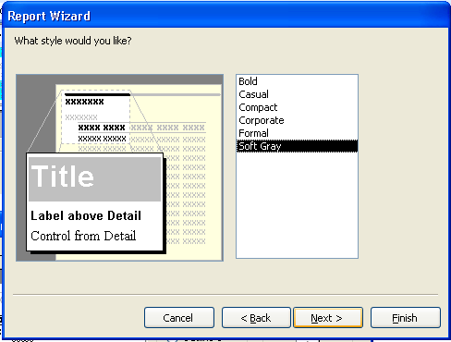
- Select a title for your report and press finish:
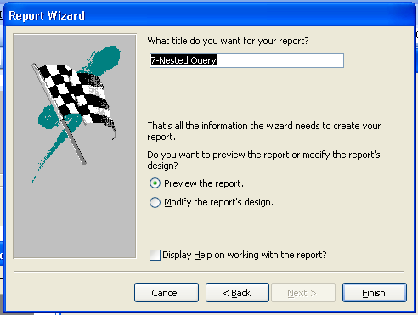
- Repeat the above steps for your JOIN query.

